**API Requirements :**

**1. Visual Studio 2017 (IDE)**2. .NET 4.5.1 (target version)  
3. Entity Framework 6.2.0 (ORM) – used **code first** to auto create tables. (auto creation is being triggered upon calling any of the api functions.)  
 Note : all the dependencies are defined in **packages.config**4. MSSQL server - any version ( for IIS deployment)

5. Basic Authentication – the username and password are not stored in DB but only in the web.config as :  
<appSettings>

<add key="BasicAuth_Username" value="ombori" />

<add key="BasicAuth_Password" value="ombori" />

</appSettings>  
  
**Running the API from Visual Studio  
 Note** : I have added a localdb/mdf file in the App_Data so that the API would run immediately even if MSSQL server is not yet installed in the local PC of the reviewer. **-** *if you wish to change the settings, you can restore commented out connection string for MSSQL on the web.config*-connection string   
<connectionStrings>

<add name="OmboriConnection" connectionString="Data Source=(LocalDb)\MSSQLLocalDB;Initial Catalog=Ombori;Integrated Security=SSPI;AttachDBFilename=|DataDirectory|\Ombori.mdf" providerName="System.Data.SqlClient" />

</connectionStrings  
  
**Deployment of the API**

**Target environment** : **Windows IIS** (Internet Information Service )  
 * please follow the link for IIS installation and setup  
 <https://www.c-sharpcorner.com/UploadFile/2b481f/how-to-host-Asp-Net-web-api-on-iis-server/>  
IIS : Create a new website and assign a new virtual folder(e.g. C:\inetpub\wwwroot\ombori) that can be used for publishing the API project from Visual Studio

* Be sure the permission for the folder is being setup for the current user/administrator or any (full control)

**Note** : before publishing the API, the database connection string in the web.config should be replaced by your own MSSQL connection and be sure the “initial catalog” or the database name is existing in your database instance . Besides MDF file is only running on IISexpress in Visual Studio.  
-connection string

<connectionStrings>

<add name="OmboriConnection" connectionString="Data Source=localhost;Initial Catalog=Ombori;Integrated Security=true" providerName="System.Data.SqlClient" />

* </connectionStrings>

**Publishing to local IIS Folder** (the folder of the new created website in IIS - C:\inetpub\wwwroot\ombori)

* Right click on the Ombori.WebAPi project then select **publish**

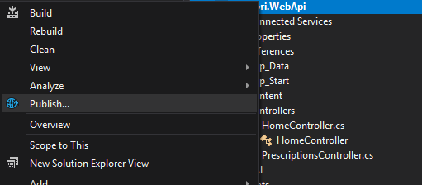

* Select the File System as Publish Method and set the target location as “C:\inetpub\wwwroot\ombori”
* Set the Configuration to **Release** and Check any of the File Publish options if needed
* Save then click on the **Publish** Button
* The list of files should look like as follows :  
  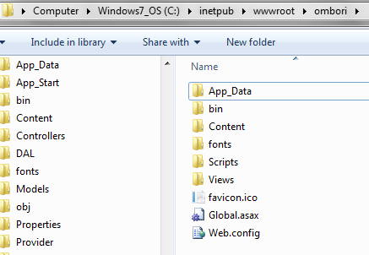
* Restart the Newly Created API Web site  
    
    
    
    
    
    
    
  **Postman test Results**
* 